***January Newsletter 2025***

ST PATRICK’S PRIMARY SCHOOL



10, Annaghmore Coalisland, Co. Tyrone. N.I. BT71 4QZ

Web Site: [www.stpatricksannaghmore.com](http://www.stpatricksannaghmore.com)

Facebook: St Patrick’s Annaghmore

Telephone :(028) 87740661

Email: info@stpatricksps.coalisland.ni.sch.uk

***Our Mission Statement.***

***“Inspired by our faith in Christ,***

***St. Patrick’s Catholic P.S. will provide:***

***A happy, secure and caring learning environment***

***Which promotes all to be the best they can be***

***Full of optimism, ambition and with a love of learning.***

***Working in partnership with our community***

***We will ensure St. Patrick’s P.S. makes a difference.”***

***Our School Prayer.***

***Dear St Patrick,***

***Help us to make our school***

***A happy, caring and safe place***

***Where we can be***

***The best we can be***

***Every day in every way,***

***Amen.***

Happy New Year

We would like to wish all our children and parents/guardians a very happy and peaceful new year.

**Break / Lunch / Dinner**

Every pupil will require a healthy break and water each day.

**Can you please ensure that you pack a healthy snack for your child**. We are trying to encourage a healthier approach to break time. Crisps and chocolate should not be eaten at breaktime.

Dinners are £2:60 per child per day or £13:00 per week.

**Please Note Correct Money Only**

**ALL dinner money MUST be paid on a Monday morning.**

**The correct money MUST be given as we are not able to provide change.**

**Dinner Menu is on the website.**

All lunch boxes and water bottles should be clearly labelled.

***Please look at the content of all snacks sent into school and check for nut content. We are a Nut Aware School due to children with allergic reactions to different types of nuts***.

**Opening Times**

School gates open at 8.50 am. Children should be in school by 9.05am at the latest to begin class at 9.10am. Please ensure your child arrives to school on time. Late comers will be marked as late on the roll.

**Attendance**

Good attendance supports learning, the development of social skills and friendships, as well as building good habits that are essential for adult life. School education lays the vital foundations of a child's life. Please ensure children attend school unless ill.

**Leaving School Early**

At times it is necessary to take your child out of school early. Children should either bring a note to the class teacher or parents / guardians should call the school secretary to arrange. **A parent or guardian must come into the school to collect the child.** Teachers cannot be contacted via our Facebook page or the website.

**Congratulations**

We congratulate Miss McVeigh on her recent wedding. Miss McVeigh will return as Mrs Kelly. We join in wishing Mr and Mrs Kelly a lifetime of health and happiness.

**Admissions to Primary 1 2025**

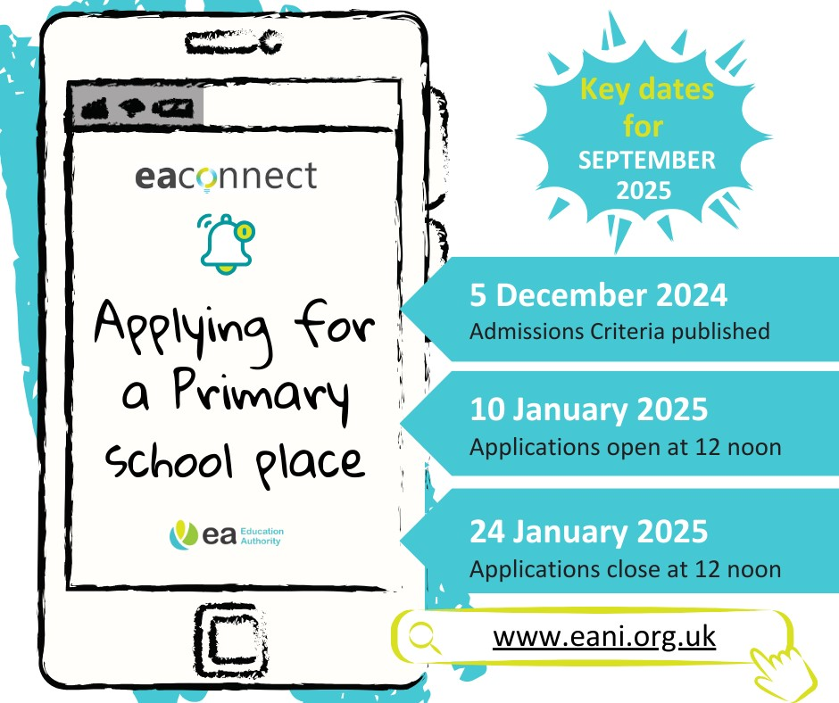**Please see our website / Facebook for link to apply online for Primary 1 2025. Applications open January 10th and close on January 24th at 12 noon**

**DATES FOR YOUR DIARY**

**Tuesday 7th January -** St Joseph’s Donaghmore for P6/7

**Thursday 9th January –** St Patrick’s Academy for P6/7

**Friday 10th January –** Admissions for P1 September 2025 open

**Monday 20th January –** Catholic School’s Week

**Friday 24th January –** Admissions for P1 September 2025 close